**Test Case – C1 Invalidation**

.

.

.

.

.

.

.

.

.

.

.

.

.

.

.

.

|  |  |
| --- | --- |
| **Version:** | 2.0 |
| **Author:** | Alexander Vejling Sennefelder |



**Document history**

|  |  |  |  |  |
| --- | --- | --- | --- | --- |
| Version | Date | Author | Status | Comments |
| 2.0 | 20-10-2022 | Emma Hagerup | Preliminary approval | Document might be subject to change |

Table of contents

1 Description 3

1.1 Test scenario 1 – C1 Acceptance 3

1.1.1 XML example 3

1.2 Test scenario 2 – C1 Rejection 4

1.2.1 XML example 4

# Pre-conditions

To complete the functional test case for “C1 Invalidation”, the company must have an established connection to the AS4 Gateway, functioning system user to DMS Export, see [Connectivity Guide&System Guide](https://github.com/skat/dms-public-private/tree/master/Onboarding%20Documents).

Furthermore, ensure that you for this test case have the correct URLs, Services, and Actions, as seen below. In place of {CVR} and {UID}, fill out your own CVR and UID in the URLs below. While the URLs and Services are the same for all the test cases, the Actions however, will change depending on the test case you are performing, please keep an eye out that you have the correct Action for the test case in hand.

To submit the XML for this test case, use the following endpoints:

|  |  |  |  |
| --- | --- | --- | --- |
| URL | UFE Service | TFE Service | Action |
| <https://secureftpgatewaytest.skat.dk:6384/exchange/CVR_{CVR}_UID_{UID}> | DMS.Export2 | DMS.Export | Declaration.Submit |
| <https://secureftpgatewaytest.skat.dk:6384/exchange/CVR_{CVR}_UID_{UID}> | DMS.Export2 | DMS.Export | Declaration.Invalidation |

For retrieving the notification, use the following endpoint:

|  |  |  |  |
| --- | --- | --- | --- |
| URL | UFE Service | TFE Service | Action |
| <https://secureftpgatewaytest.skat.dk:6384/exchange/CVR_{CVR}_UID_{UID}> | DMS.Export2 | DMS.Export | Notification |

Please ensure that the “**Test Case – C1 Standard**” have been completed **before** you try to complete the **“Test Case – C1 Invalidation”** scenarios.

## Process flow

The process flow for a C1 standard declaration with an invalidation request can be seen in Figure 1 below:

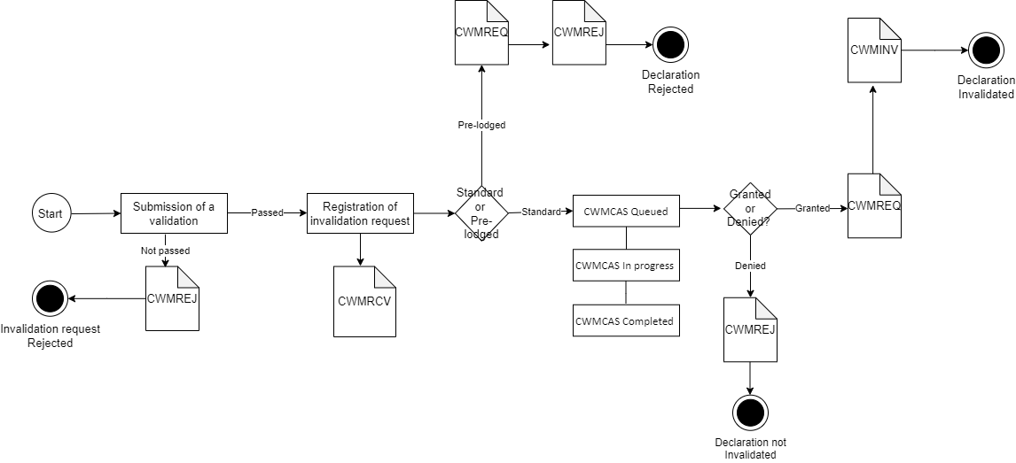

# Test Scenarios

To complete this test case, test scenario 1 and 2 must be passed successfully. Descriptions and specifics for each test can be found in the coming sections. Be sure to go through the scenarios thoroughly. It is recommended that you use the attached files to test the notifications.

|  |  |  |
| --- | --- | --- |
| Test no. | Test scenario | Passed/Failed |
| 1 | Submit C1 – Invalidation, which is accepted | ☐ |
| 2 | Submit C1 – Invalidation, which is rejected | ☐ |

## Description of test scenarios

The following sections will describe the aim of each specific scenario and provide the desired results of the test scenarios. It is worth noting that there can be changes in the notifications provided by DMS Export as the solution is still in development.

The purpose of the test scenarios is to ensure your connection to the system, and that you as a company can receive the correct notifications when sending in XMLs. Each step describes what you need to do when going through the test case. For each case there will be an XML available in the same folder where you found this test case document.

## Test scenario 1 – Acceptance

The aim of this scenario is to get a notification that the C1 Invalidation XML has been accepted.

The following table shows the necessary test steps for completing this scenario as well as expected results. For the first step it is recommended using the provided declaration **XML** found in the **Test Case** folder. Secondly, make sure that your **LRN** is unique, and that the **Submitter** field is correct (this is done by putting your CVR in the **Submitter/Name** and **Submitter/ID** fields) in the C1 Standard XML. You should also make sure that the **Amendment** field is filled with a valid **ChangeReasonCode** and a **ChangeReasonText** of at least 10 characters, as described in step no. 5.

|  |  |  |  |
| --- | --- | --- | --- |
| Step no. | Description of steps | Expected result | Passed |
| 1 | Submit a **C1 Standard Acceptance XML** (you can use the C1 Standard Acceptance XML from the C1 Standard test case). It is found in folder where you found this test case document folder (remember to replace the **{{LRN}}** and **{{CVR}}** placeholders) | You should have a template **XML** ready for the next step | ☐ |
| 2 | Submit the declaration using the conditions found under Pre-conditions | The declaration should be sent to the system | ☐ |
| 3 | Pull the notifications | You should be able to pull the notification from the system | ☐ |
| 4 | Acceptance of submission of declaration | Receive the **CWMACC** notifications | ☐ |
| 5 | Use your own invalidation XML or the **C1 Invalidation Acceptance XML** found in the test case folder (remember to replace the **{{LRN}}** and **{{CVR}}** placeholders).  Make sure that the **Amendment** field is filled in as shown in section 2.2.1 | Find the **C1 Invalidation Acceptance XML** in the amendment test case folder or use your own | ☐ |
| 6 | Send in an C1 **Invalidation Acceptance XML**, it can be found in the same folder as this test case. Remember to add the **LRN** and **MRN** from the initially submitted C1 Standard XML. | The **C1** **Invalidation Acceptance XML** should be sent to the system | ☐ |
| 7 | Pull the notifications | You should be able to pull notification from the system | ☐ |
| 8 | Successful validation of submission of invalidation request by receiving the **CWMRCV** and **CWMCAS** notifications | You should receive the **CWMRCV** and **CWMCAS** notifications | ☐ |
| 9 | After having received the **CWMCAS**, read the **AdditionalInformation** field regarding the status. | You should find a **StatementCode** field with the number **41** (CWMCAS Queued). Then in the **StatementDescription** field there should be an explanation | ☐ |
| 10 | Once the queued request is completed, receive another **CWMCAS** notification with changes to **AdditionalInformation**. | You should find the **StatementCode** field should now be **43** (CWMCAS Completed) | ☐ |
| 11 | Acceptance of submission of invalidation request by receiving the **CWMREQ** and **CWMINV** notifications | Receive notifications **CWMREQ** and **CWMINV** and pass the test | ☐ |

### XML example

<ns3:Amendment>

        <ns3:SequenceNumeric>1</ns3: SequenceNumeric >

        <ns3:ChangeReasonCode>22</ns3:ChangeReasonCode>

        <ns3:ChangeReasonCode>Goods have been returned to supplier</ns3:ChangeReasonCode>

</ns3:Amendment>

## Test scenario 2 – Rejection

The aim of this scenario is for the EO to get a notification that the C1 Invalidation XML has been rejected.

The following table shows the test steps necessary to complete this scenario as well as expected results. For the first step it is recommended using the provided declaration **XML** found in the **Test Case** folder. Secondly, make sure that your **LRN** is unique, and that the **Submitter** field is correct (this is done by putting your CVR in the **Submitter/Name** and **Submitter/ID** fields) in the C1 Standard XML. In this case we will fill in invalid data end the **Amendment** field with a valid **ChangeReasonCode** but a **ChangeReasonText** of less than 10 characters, as described in step no. 5.

|  |  |  |  |
| --- | --- | --- | --- |
| Step no. | Description of steps | Expected result | Passed |
| 1 | Submit a C1 Standard Acceptance XML (you can use the C1 Standard Acceptance XML from the C1 Standard test case). It is found in folder where you found this test case document folder (remember to replace the **{{LRN}}** and **{{CVR}}** placeholders) | You should have a template **XML** ready for the next step | ☐ |
| 2 | Submit the declaration using the conditions found under Pre-conditions | The declaration should be sent to the system | ☐ |
| 3 | Pull the notifications | You should be able to pull the notification from the system | ☐ |
| 4 | Acceptance of submission of declaration | Receive the **CWMACC**  notifications | ☐ |
| 5 | Use your own invalidation XML or the **C1 Invalidation Rejection XML** found in the test case folder (remember to replace the **{{LRN}}** and **{{CVR}}** placeholders).  Make sure that the **Amendment** field is filled in as shown in section 2.3.1 | Find the **C1 Invalidation Rejection XML** in the amendment test case folder or use your own | ☐ |
| 6 | Send in an **C1 Invalidation Rejection XML**, it can be found in the same folder as this test case. Remember to add the **LRN** and **MRN** from the initially submitted C1 Standard XML. | The **C1 Invalidation Rejection XML** should be sent to the system | ☐ |
| 7 | Pull the notifications | You should be able to pull notification from the system | ☐ |
| 8 | Rejection of submission of invalidation request by receiving the **CWMREJ** notification | Receive notification **CWMREJ** and pass the scenario | ☐ |

### XML example

<ns3:Amendment>

        <ns3:SequenceNumeric>1</ns3: SequenceNumeric >

        <ns3:ChangeReasonCode>22</ns3:ChangeReasonCode>

        <ns3:ChangeReasonCode>Invalid</ns3:ChangeReasonCode>

</ns3:Amendment>